

NAME: BISMA FATIMA
CLASS: CS A
ROLL NO: F24605036
COURSE: ARTIFICIAL INTELLIGENCE
COURSE CODE: CS-281
LECTURER: SIR IJLAL HAIDER

LAB 05

IN LAB TASKS
TASK 01:
Traverse the given graph with A as the starting and G as the Goal using greedy best first search. The heuristics value of reaching the goal G from current node is represented along each node.
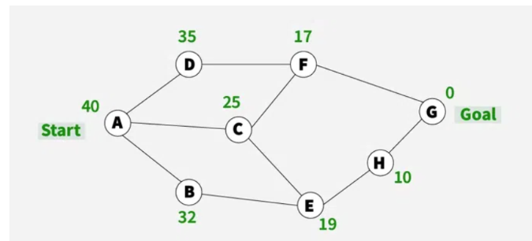
PROGRAM
1. import heapq
2.
3. # Define the graph as an adjacency list with edge weights
4. graph = {
5. 'A': {'D': 35, 'C': 25, 'B': 32, 'F': 17},
6. 'B': {},
7. 'C': {'F': 25, 'E': 19},
8. 'D': {'F': 17},
9. 'E': {'H': 10},
10. 'F': {},
11. 'H': {'G': 0},
12. 'G': {}
13. }
14.
15. # Heuristic values for each node (example values)
16. heuristics = {
17. 'A': 40,
18. 'B': 35,
19. 'C': 30,
20. 'D': 25,
21. 'E': 20,
22. 'F': 15,
23. 'H': 5,
24. 'G': 0
25. }
26.
27. def greedy_best_first_search(start, goal):
28. visited = set()
29. priority_queue = []
30. heapq.heappush(priority_queue, (heuristics[start], start))
31. came_from = {start: None}
32.
33. while priority_queue:
34. _, current = heapq.heappop(priority_queue)
35.
36. if current == goal:
37. break
38.
39. visited.add(current)
40.
41. for neighbor in graph[current]:
42. if neighbor not in visited:
43. heapq.heappush(priority_queue, (heuristics[neighbor], neighbor))
44. if neighbor not in came_from:
45. came_from[neighbor] = current
46.
47. # Reconstruct path
48. path = []
49. node = goal
50. while node:
51. path.append(node)
52. node = came_from.get(node)
53. path.reverse()
54.
55. return path
56.
57. # Run the search
58. path = greedy_best_first_search('A', 'G')
59. print("Greedy Best-First Search Path:", " → ".join(path))

OUTPUT
Task 2
Traverse the given tree with S as the root node and G as the Goal using greedy best first search. The heuristics value of reaching the goal G from current node is represented in the table.
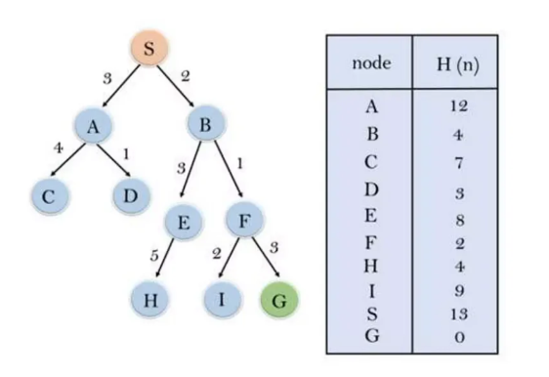
PROGRAM
1. import heapq
2.
3. # Tree structure with edge costs
4. tree = {
5. 'S': {'A': 3, 'B': 2},
6. 'A': {'C': 4, 'D': 1},
7. 'B': {'E': 3, 'F': 1},
8. 'E': {'H': 5},
9. 'F': {'I': 2},
10. 'I': {'G': 3},
11. 'C': {}, 'D': {}, 'H': {}, 'G': {}
12. }
13.
14. # Heuristic values from the table
15. heuristics = {
16. 'A': 12,
17. 'B': 4,
18. 'C': 7,
19. 'D': 3,
20. 'E': 8,
21. 'F': 2,
22. 'H': 9,
23. 'I': 13,
24. 'G': 0
25. }
26.
27. def greedy_best_first_search(start, goal):
28. visited = set()
29. priority_queue = []
30. heapq.heappush(priority_queue, (heuristics.get(start, 0), start))
31. came_from = {start: None}
32.
33. while priority_queue:
34. _, current = heapq.heappop(priority_queue)
35.
36. if current == goal:
37. break
38.
39. visited.add(current)
40.
41. for neighbor in tree.get(current, {}):
42. if neighbor not in visited:
43. heapq.heappush(priority_queue, (heuristics[neighbor], neighbor))
44. if neighbor not in came_from:
45. came_from[neighbor] = current
46.
47. # Reconstruct path
48. path = []
49. node = goal
50. while node:
51. path.append(node)
52. node = came_from.get(node)
53. path.reverse()
54.
55. return path
56.
57. # Run the search
58. path = greedy_best_first_search('S', 'G')
59. print("Greedy Best-First Search Path:", " → ".join(path))

OUTPUT
Task 3:
Traverse the given graph with A as the starting node and J as the goal using A* search. The heuristics value of reaching the goal J from current node is represented on the nodes. The cost of each reaching from current node to next node is represented along the edges.

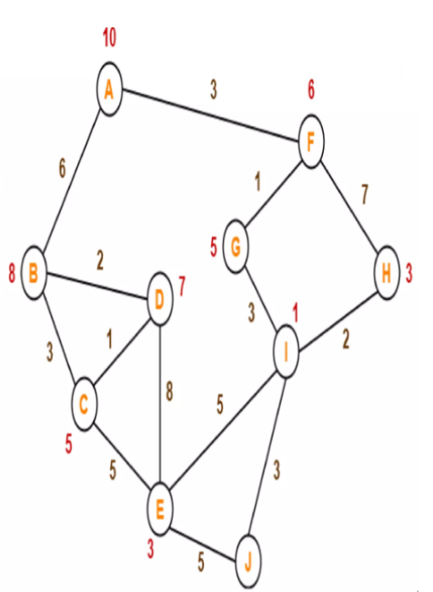
PROGRAM
1. import heapq
2.
3. # Graph with edge weights
4. graph = {
5. 'A': {'B': 6, 'D': 3, 'F': 6, 'G': 1},
6. 'B': {'A': 6, 'C': 3, 'D': 2},
7. 'C': {'B': 3, 'D': 1, 'E': 7},
8. 'D': {'A': 3, 'B': 2, 'C': 1, 'E': 8, 'G': 5},
9. 'E': {'C': 7, 'D': 8, 'I': 5, 'J': 5},
10. 'F': {'A': 6, 'G': 1, 'H': 7},
11. 'G': {'A': 1, 'D': 5, 'F': 1, 'I': 3},
12. 'H': {'F': 7, 'I': 2},
13. 'I': {'G': 3, 'H': 2, 'E': 5, 'J': 1},
14. 'J': {'E': 5, 'I': 1}
15. }
16.
17. # Heuristic values
18. heuristics = {
19. 'A': 10, 'B': 8, 'C': 3, 'D': 2, 'E': 3,
20. 'F': 6, 'G': 5, 'H': 7, 'I': 1, 'J': 3
21. }
22.
23. def a_star_search(start, goal):
24. open_set = []
25. heapq.heappush(open_set, (heuristics[start], 0, start))
26. came_from = {start: None}
27. g_score = {start: 0}
28.
29. while open_set:
30. _, current_g, current = heapq.heappop(open_set)
31.
32. if current == goal:
33. break
34.
35. for neighbor, cost in graph[current].items():
36. tentative_g = current_g + cost
37. if neighbor not in g_score or tentative_g < g_score[neighbor]:
38. g_score[neighbor] = tentative_g
39. f_score = tentative_g + heuristics[neighbor]
40. heapq.heappush(open_set, (f_score, tentative_g, neighbor))
41. came_from[neighbor] = current
42.
43. # Reconstruct path
44. path = []
45. node = goal
46. while node:
47. path.append(node)
48. node = came_from.get(node)
49. path.reverse()
50.
51. return path
52.
53. # Run the search
54. path = a_star_search('A', 'J')
55. print("A* Search Path:", " → ".join(path))

OUTPUT


POST LAB TASK
Task 1
Write a Python program that implements the Greedy Best-First Search algorithm using a graph representation created with a Node class. Each node in the graph should represent a point in the environment and can be connected to other nodes via edges. Your implementation should be able to find a path from a specified start node to a goal node. Implement the algorithm using both Euclidean distance and Manhattan distance as heuristics to estimate the cost from the current node to the goal node.
Hints:
Euclidean Distance: (x1-x2) 2 +(y1- y2) 2
Manhattan Distance: x1-x2+ y1- y2
PROGRAM
1. import heapq
2. import math
3.
4. # Node class with coordinates and neighbors
5. class Node:
6. def __init__(self, name, x, y):
7. self.name = name
8. self.x = x # X-coordinate
9. self.y = y # Y-coordinate
10. self.neighbors = [] # List of tuples: (neighbor_node, edge_cost)
11.
12. def add_neighbor(self, neighbor, cost):
13. self.neighbors.append((neighbor, cost))
14.
15. # Heuristic: Euclidean distance
16. def euclidean_distance(node, goal):
17. return math.sqrt((goal.x - node.x)**2 + (goal.y - node.y)**2)
18.
19. # Heuristic: Manhattan distance
20. def manhattan_distance(node, goal):
21. return abs(goal.x - node.x) + abs(goal.y - node.y)
22.
23. # Greedy Best-First Search algorithm
24. def greedy_best_first_search(start, goal, heuristic_func):
25. visited = set()
26. priority_queue = []
27. heapq.heappush(priority_queue, (heuristic_func(start, goal), start))
28. came_from = {start.name: None}
29.
30. while priority_queue:
31. _, current = heapq.heappop(priority_queue)
32.
33. if current.name == goal.name:
34. break
35.
36. visited.add(current.name)
37.
38. for neighbor, _ in current.neighbors:
39. if neighbor.name not in visited:
40. heapq.heappush(priority_queue, (heuristic_func(neighbor, goal), neighbor))
41. if neighbor.name not in came_from:
42. came_from[neighbor.name] = current.name
43.
44. # Reconstruct path
45. path = []
46. node_name = goal.name
47. while node_name:
48. path.append(node_name)
49. node_name = came_from.get(node_name)
50. path.reverse()
51.
52. return path
53.
54. # Example usage
55. if __name__ == "__main__":
56. # Create nodes with coordinates
57. A = Node('A', 0, 0)
58. B = Node('B', 2, 1)
59. C = Node('C', 4, 2)
60. D = Node('D', 1, 3)
61. E = Node('E', 3, 4)
62. F = Node('F', 5, 5)
63.
64. # Define edges
65. A.add_neighbor(B, 2)
66. A.add_neighbor(D, 3)
67. B.add_neighbor(C, 2)
68. B.add_neighbor(E, 4)
69. D.add_neighbor(E, 2)
70. E.add_neighbor(F, 3)
71. C.add_neighbor(F, 2)
72.
73. # Run GBFS with Euclidean
74. path_euclidean = greedy_best_first_search(A, F, euclidean_distance)
75. print("Path using Euclidean heuristic:", " → ".join(path_euclidean))
76.
77. # Run GBFS with Manhattan
78. path_manhattan = greedy_best_first_search(A, F, manhattan_distance)
79. print("Path using Manhattan heuristic:", " → ".join(path_manhattan))

OUTPUT
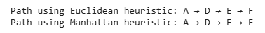
Task 2
Write a Python program that implements the A* Search algorithm using a graph representation created with a Node class. Each node in the graph should represent a point in the environment and can be connected to other nodes via edges. Your implementation should be able to find a path from a specified start node to a goal node. Implement the algorithm using both Euclidean distance and Manhattan distance as heuristics to estimate the cost from the current node to the goal node.
PROGRAM
1. import heapq
2. import math
3.
4. # Node class with coordinates and neighbors
5. class Node:
6. def __init__(self, name, x, y):
7. self.name = name
8. self.x = x # X-coordinate
9. self.y = y # Y-coordinate
10. self.neighbors = [] # List of tuples: (neighbor_node, edge_cost)
11.
12. def add_neighbor(self, neighbor, cost):
13. self.neighbors.append((neighbor, cost))
14.
15. # Heuristic: Euclidean distance
16. def euclidean_distance(node, goal):
17. return math.sqrt((goal.x - node.x)**2 + (goal.y - node.y)**2)
18.
19. # Heuristic: Manhattan distance
20. def manhattan_distance(node, goal):
21. return abs(goal.x - node.x) + abs(goal.y - node.y)
22.
23. # A* Search algorithm
24. def a_star_search(start, goal, heuristic_func):
25. open_set = []
26. heapq.heappush(open_set, (heuristic_func(start, goal), 0, start))
27. came_from = {start.name: None}
28. g_score = {start.name: 0}
29.
30. while open_set:
31. _, current_g, current = heapq.heappop(open_set)
32.
33. if current.name == goal.name:
34. break
35.
36. for neighbor, cost in current.neighbors:
37. tentative_g = current_g + cost
38. if neighbor.name not in g_score or tentative_g < g_score[neighbor.name]:
39. g_score[neighbor.name] = tentative_g
40. f_score = tentative_g + heuristic_func(neighbor, goal)
41. heapq.heappush(open_set, (f_score, tentative_g, neighbor))
42. came_from[neighbor.name] = current.name
43.
44. # Reconstruct path
45. path = []
46. node_name = goal.name
47. while node_name:
48. path.append(node_name)
49. node_name = came_from.get(node_name)
50. path.reverse()
51.
52. return path
53.
54. # Example usage
55. if __name__ == "__main__":
56. # Create nodes with coordinates
57. A = Node('A', 0, 0)
58. B = Node('B', 2, 1)
59. C = Node('C', 4, 2)
60. D = Node('D', 1, 3)
61. E = Node('E', 3, 4)
62. F = Node('F', 5, 5)
63.
64. # Define edges
65. A.add_neighbor(B, 2)
66. A.add_neighbor(D, 3)
67. B.add_neighbor(C, 2)
68. B.add_neighbor(E, 4)
69. D.add_neighbor(E, 2)
70. E.add_neighbor(F, 3)
71. C.add_neighbor(F, 2)
72.
73. # Run A* with Euclidean
74. path_euclidean = a_star_search(A, F, euclidean_distance)
75. print("A* Path using Euclidean heuristic:", " → ".join(path_euclidean))
76.
77. # Run A* with Manhattan
78. path_manhattan = a_star_search(A, F, manhattan_distance)
79. print("A* Path using Manhattan heuristic:", " → ".join(path_manhattan))

OUTPUT
